GEOGRAPHY FORM 1 MARKING KEY TERM 1 OF 2025/26
Section A (20 marks)

- D
- A
- C
- C
- C
- B
- A
- C
- C
- A
- A
- C
- C
- C
- A
- C
- C
- A
- A
- D

Section B

- i. 7585 1 mark
ii. 733840 2 marks
- North west 2 marks
- 3.6km =4km 2 marks
- Agriculture/farming -transportation –settlement –quarrying
any 2 points 2 marks
- 111◦ 0r 112◦ or 113◦
- Linear settlement - nucleated/compacted/clustered
- $Area=(complete+\frac{incomplete square }{2}$ x ${1km}^{2}$ 1
$area=\left(8+ \frac{10}{2}\right)×{1km}^{2}$ 1
$area=8+5 x 1{km}^{2} 1$
=13.0 x $1km^{2}$1
$=13.0km^{2} 1$
=13km² 1 (6 marks)

- Refers to the sun ,planets and other heavenly bodies 2 marks

- Has right gases for breathing e.g nitrogen and oxygen
- Earth’s atmosphere protects life from harmful radiation
- Contains water making it possible for life
- It is not too far or too close to the sun
any 2 points 4 marks
c. a meteor is a small particle from space that when enters the
earth atmosphere it burn up completely while a meteorite is a
big meteor that do not completely burn up and it lands on the
earth surface. 2 marks
d. do not clear its path or orbit
They are too numerous and too small to be called planets
It lacks gravitational power to sweep up and scatter objects near its path 2 marks
23. a. Title_ shows name of covered on the map
key/legend_ collection of map symbols and signs
scale_ relationship between distance on the map and actual
distance on the surface
frame/margin _forms the boundary on the map
compass _ indicates the direction on the map
any 3 points 6 marks
b. i. 1 cm on the map represent 50,000cm on the actual ground
(1cm to represent 0.5km on the ground) 2 marks
ii. NOTE: SPACING ON THE LINEAR SCALE SHOULD BE
2 CM APART( since 50,000cm is half of a km)
3 marks
C. i. by using a piece of paper
ii by using a string
iii. By using a piece of paper
24. 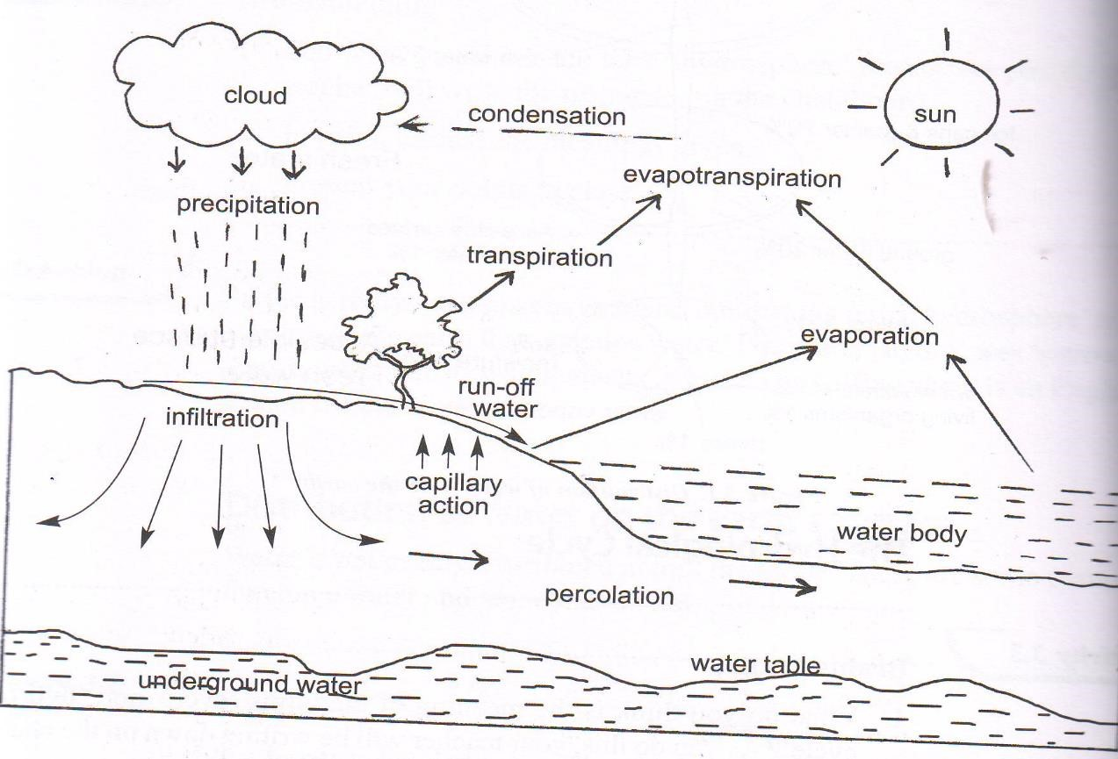

Students should draw the water cycle and correctly label the sun, infiltration,pecoration, evaporation and transpiration 6 marks

SECTION C
STUDENTS MUST WRITE THE FOLLOWING POINTS IN AN ESSAY FORM
25
- Afforestation and reforestation
- Use of clean sources of energy that does not cause air pollution
- Prevent bushfires
- Use of better farming methods
- Civic education ( Note: any 5 points, each point and an explanation carries 3marks)
26
- Aerial photographs
- Sunrise and sunset
- circumnavigation
- the lunar eclipse/ eclipse of the moon
- ship’s visibility
- earth curved horizon
- surveying with poles on a level ground ( Note: any 5 points, each point and an explanation carries 3marks)

The end

